**Objective Questions**

1. In analyzing the hospital dataset with Power BI, ensure data cleaning to address inconsistencies and missing values before further analysis.

**Observation:** To enhance the efficiency of data analysis, I implemented the following transformations on the dataset:

**-**The dataset and header names have been corrected to enhance readability.

- Appropriate data types have been assigned to all columns based on the nature of the values they store.

To handle missing values in the "patient_sat_score" column, I utilized the fill-down method to populate values in adjacent empty cells.

- I divided Date and Time values into separate columns to improve data readability.

- In the "Patient Gender" column, I replaced 'M' with 'Male' and 'F' with 'Female'.

- I combined the Patient's First and Last Name into a single cell to obtain the complete Patient's name.

- Patient Age was categorized into different age groups using DAX.

- Satisfaction Level was assessed based on the provided satisfaction score using DAX.

- Wait time was grouped into five categories using DAX.

1. **Assess the Average Waiting Time:** Analyse the patient waits times to identify the average duration a patient spends before receiving care.

**Visualization:**

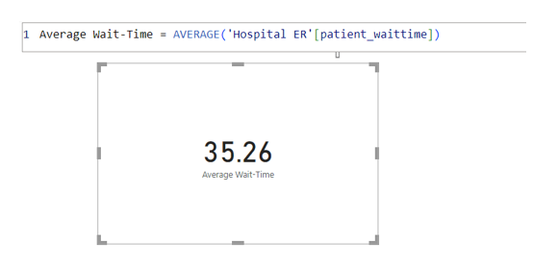

**Observation:** On average, patients wait for approximately 35.26 minutes before receiving care. Average Wait time (in min) = AVERAGE ('Hospital Patient dataset'[Patient Waittime])

1. **Visits by Department Referral:** Calculate the total number of visits to each department based on referrals to understand which departments are most frequently visited*.*

**Visualization*:***

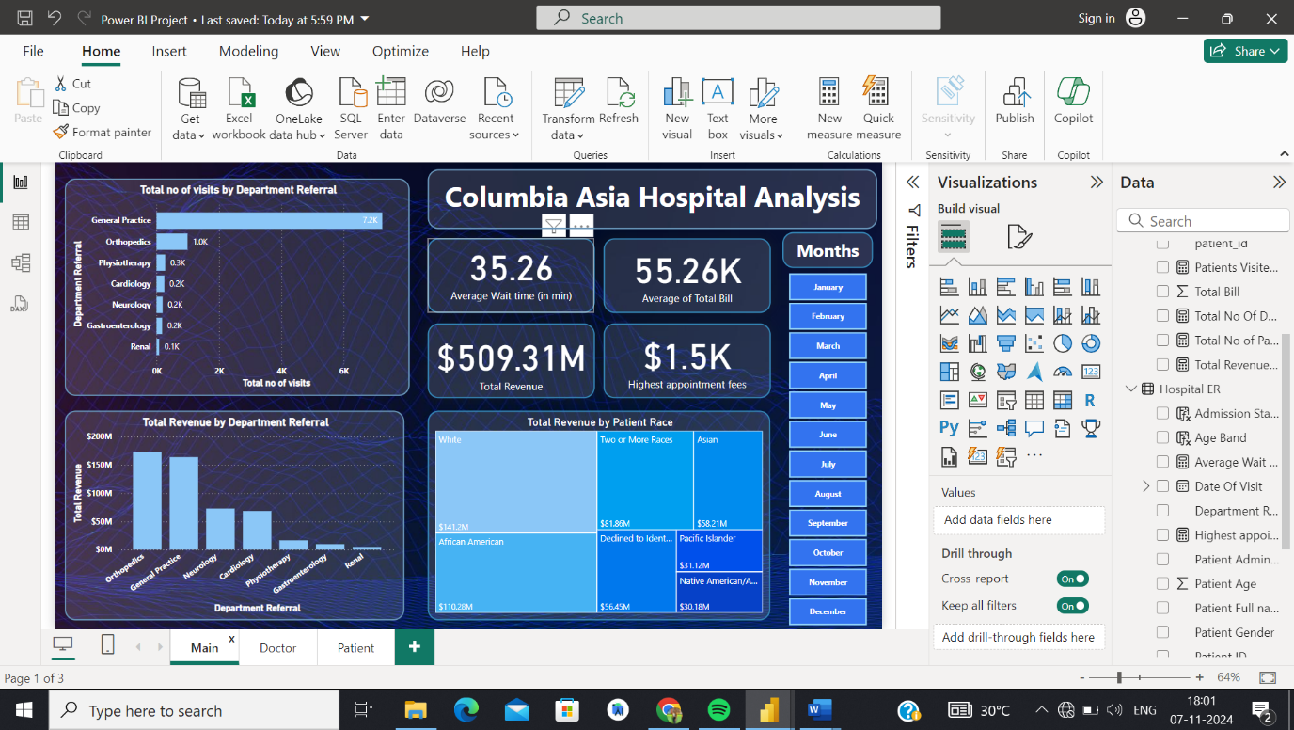

**Observation:** The General Practice department, with 7240 patients, records the highest number of patient visits based on referrals, while Orthopaedics, with 995 patients, ranks as the second most visited department

1. **Patient Visits by Age Group**: Segregate patient visits according to different age groups to see which demographics utilize healthcare services the most.

**Solution:** To begin segregating visits by age groups, we must first define a calculated column that categorizes patients into these groups, using the formula:

**Visualization:**

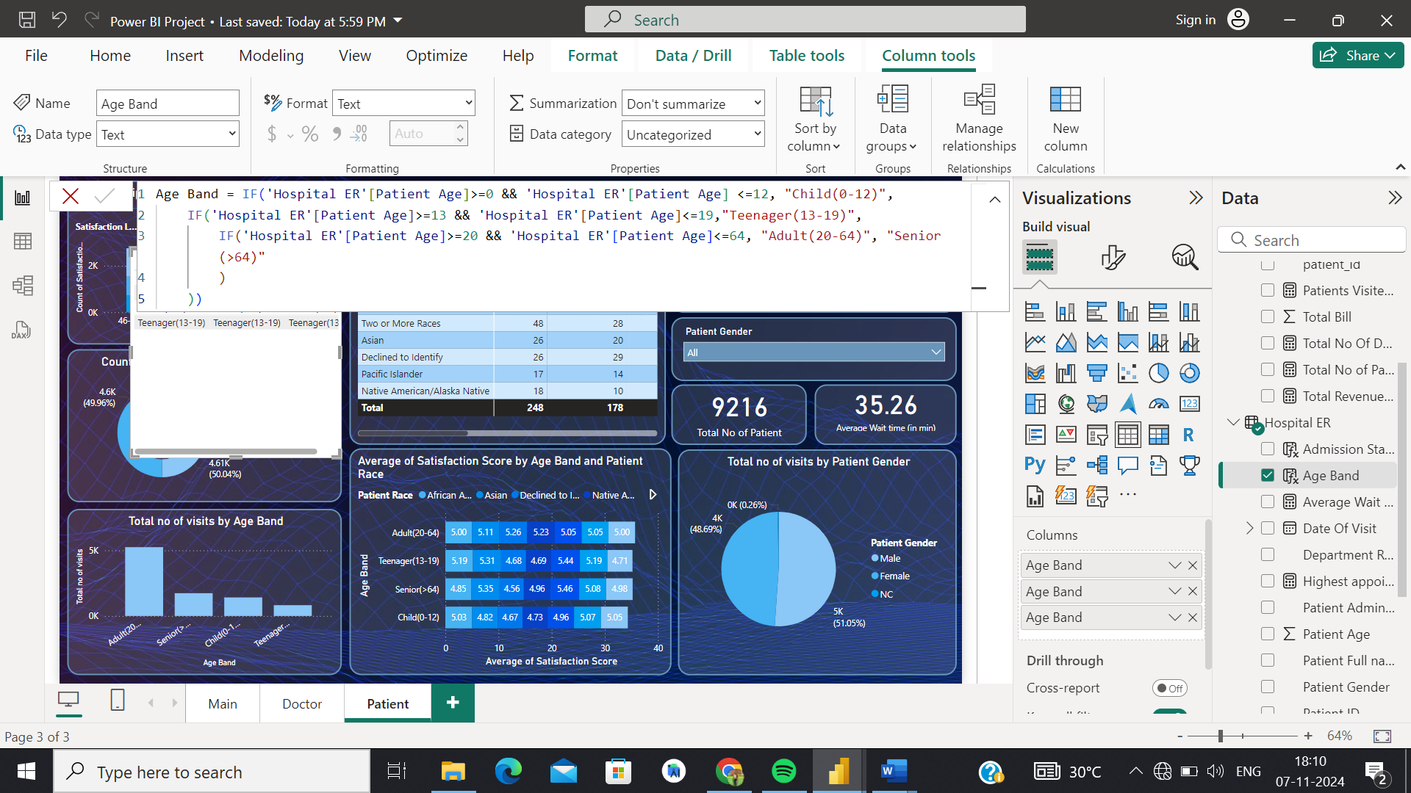

After this, we generate a bar chart against the ‘date_visited’ column:

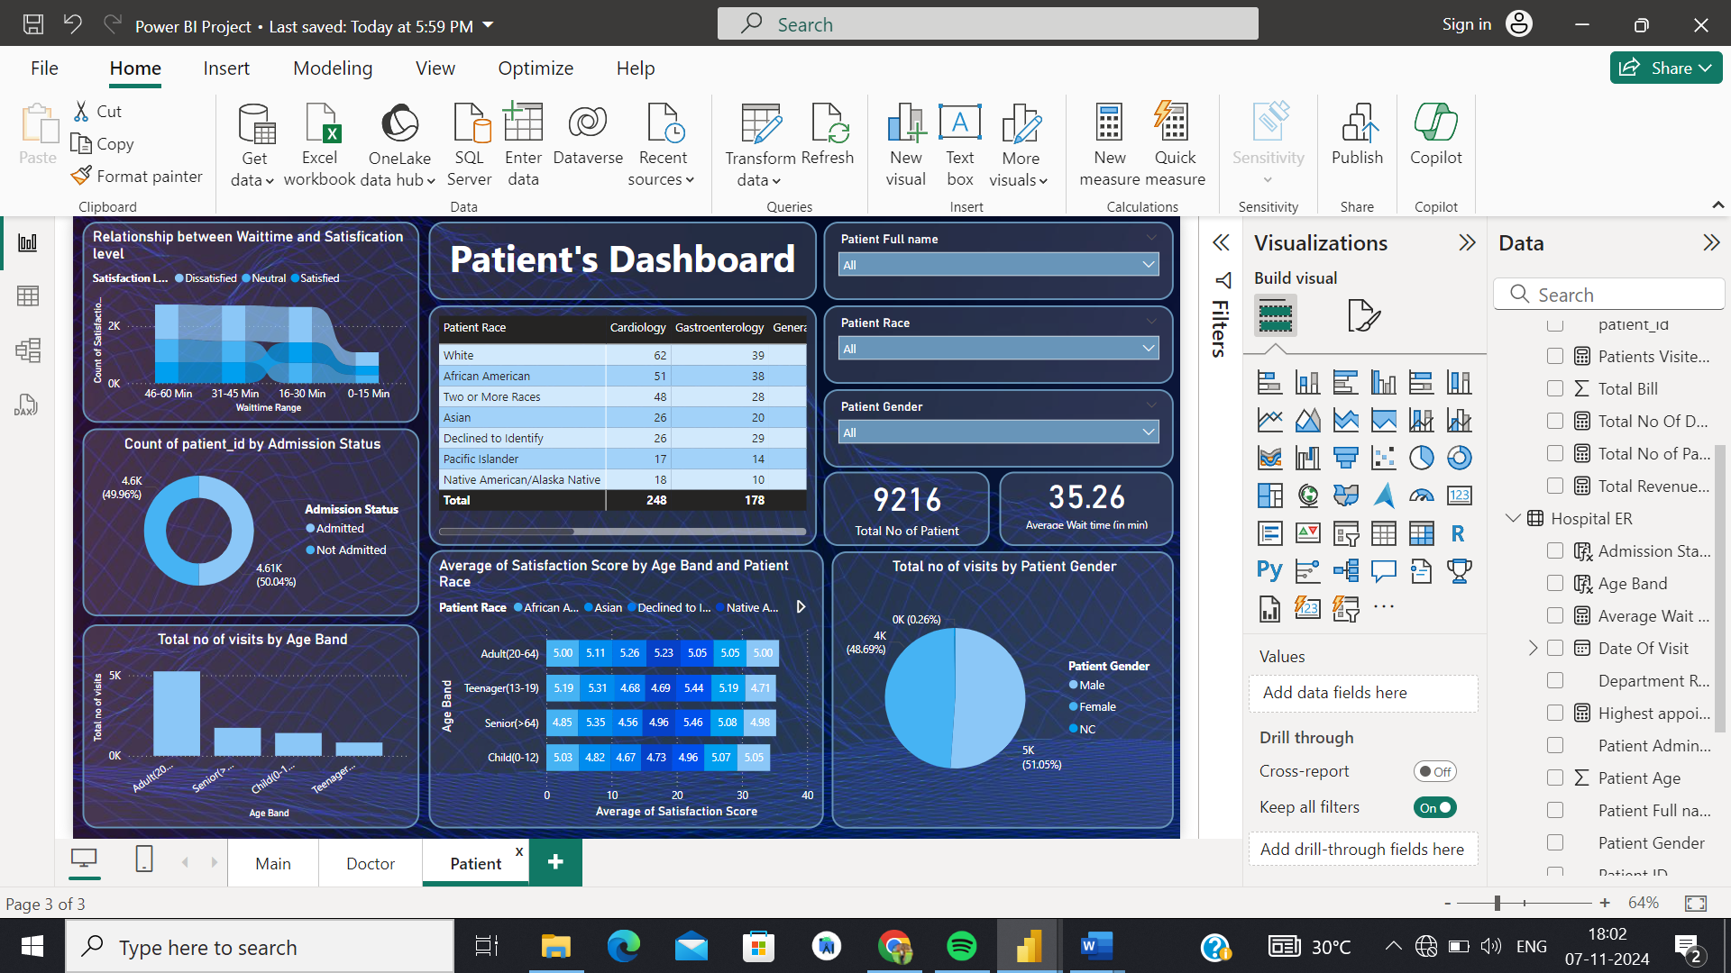

Based on the current data from Columbia Asia Hospital, the age group with the highest number of patient visits is adults (20-64 years).

1. Were there any Null values in the data? What would be the best way to handle these Null values and which approach have you opted for?

**Observation:** Yes, there are Null values specifically within the column ‘patient_sat_score’. In this case, I utilized the fill-down method to populate values in adjacent empty cells.

1. Is there any relation between the number of visits and the Gender of the patients?

**Visualization:**



**Observation :** To visualize the relationship between gender and the number of visits, I used a pie chart to display the distribution of patient visits by gender. This chart reveals that Male patients account for approximately 51.05% of total visits, while Female patients represent around 48.69%. Non-Confirmed (NC) patients, if present, make up a very small fraction of the total visits.

1. **Average Satisfaction by Demographics: Determine the relationship between patient satisfaction scores, their age groups, and racial backgrounds to pinpoint areas for improvement in patient experience.**

**Visualization:**

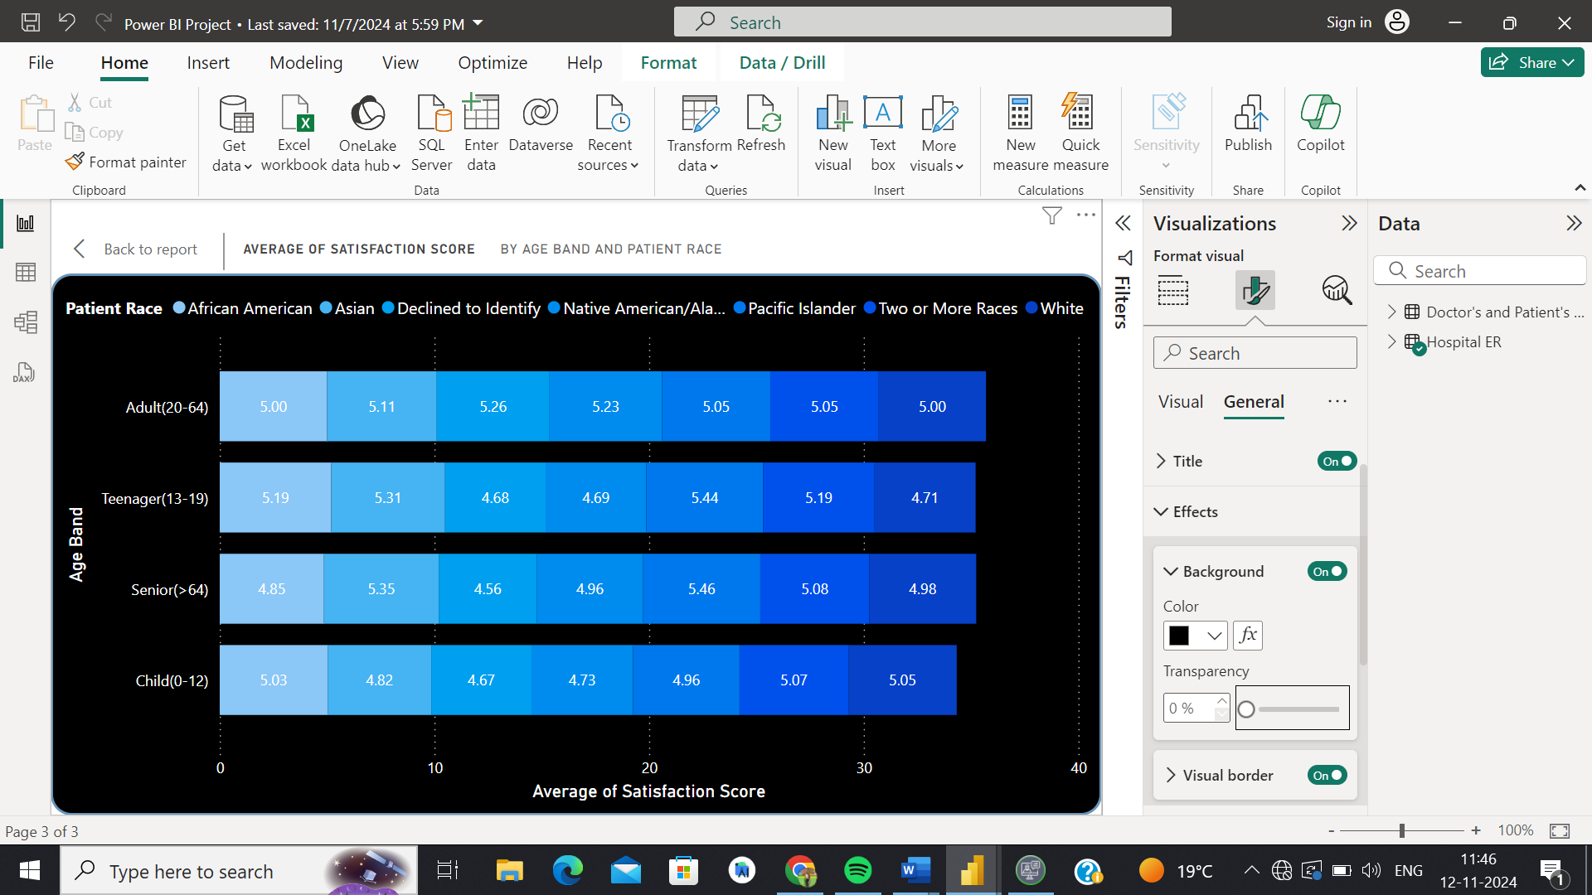

**Observation:** To determine the relationship between patient satisfaction scores, their age groups, and racial backgrounds, we can use the stacked bar chart visualization, taking averages of satisfaction scores for every age group, and race.

We find that, among younger patients [ages 0-19], Two or More Races and pacific islander offer the most favorable ratings, while among adults[20-64] native americans/Alaska native and for Senior patients pacific islander.

1. The hospital's managing director seeks to evaluate the revenue of each department to understand how much revenue is generated by each.

**Visualization:**

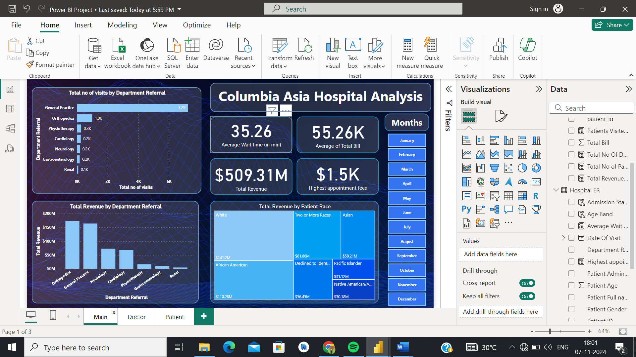

**Observation**: Used the stacked column chart for total revenue against department referrals. The Orthopaedics department generates the highest revenue, amounting to INR 172,939,773, while the General Practice department, with a revenue of INR 164,070,816, secures the second position in revenue generation.

1. Which department is charging the highest appointment fees in general? Use an aggregation DAX function to solve this question.

**Visualization:**

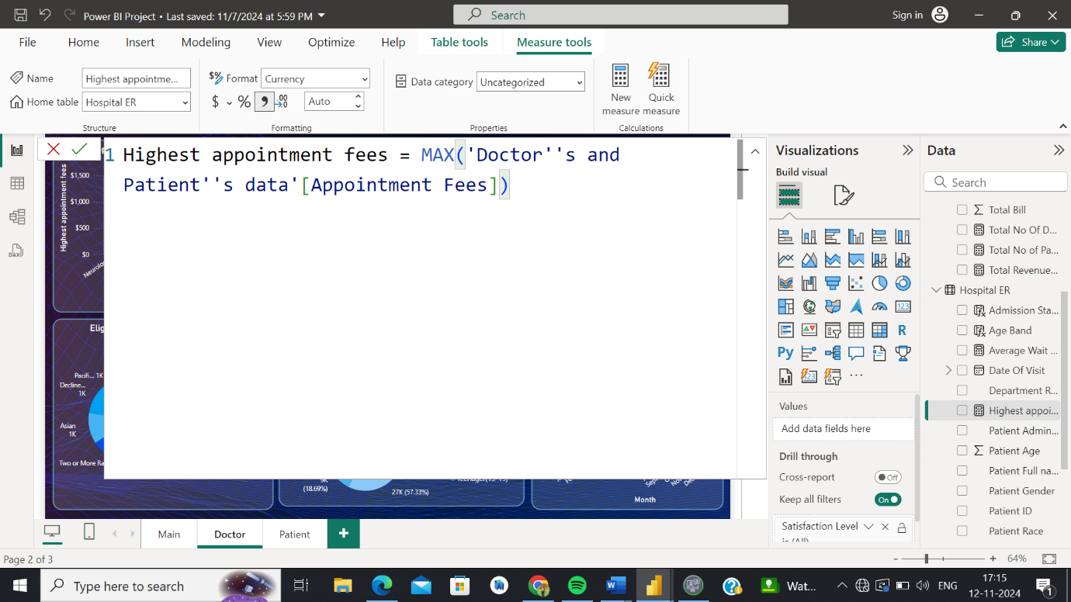

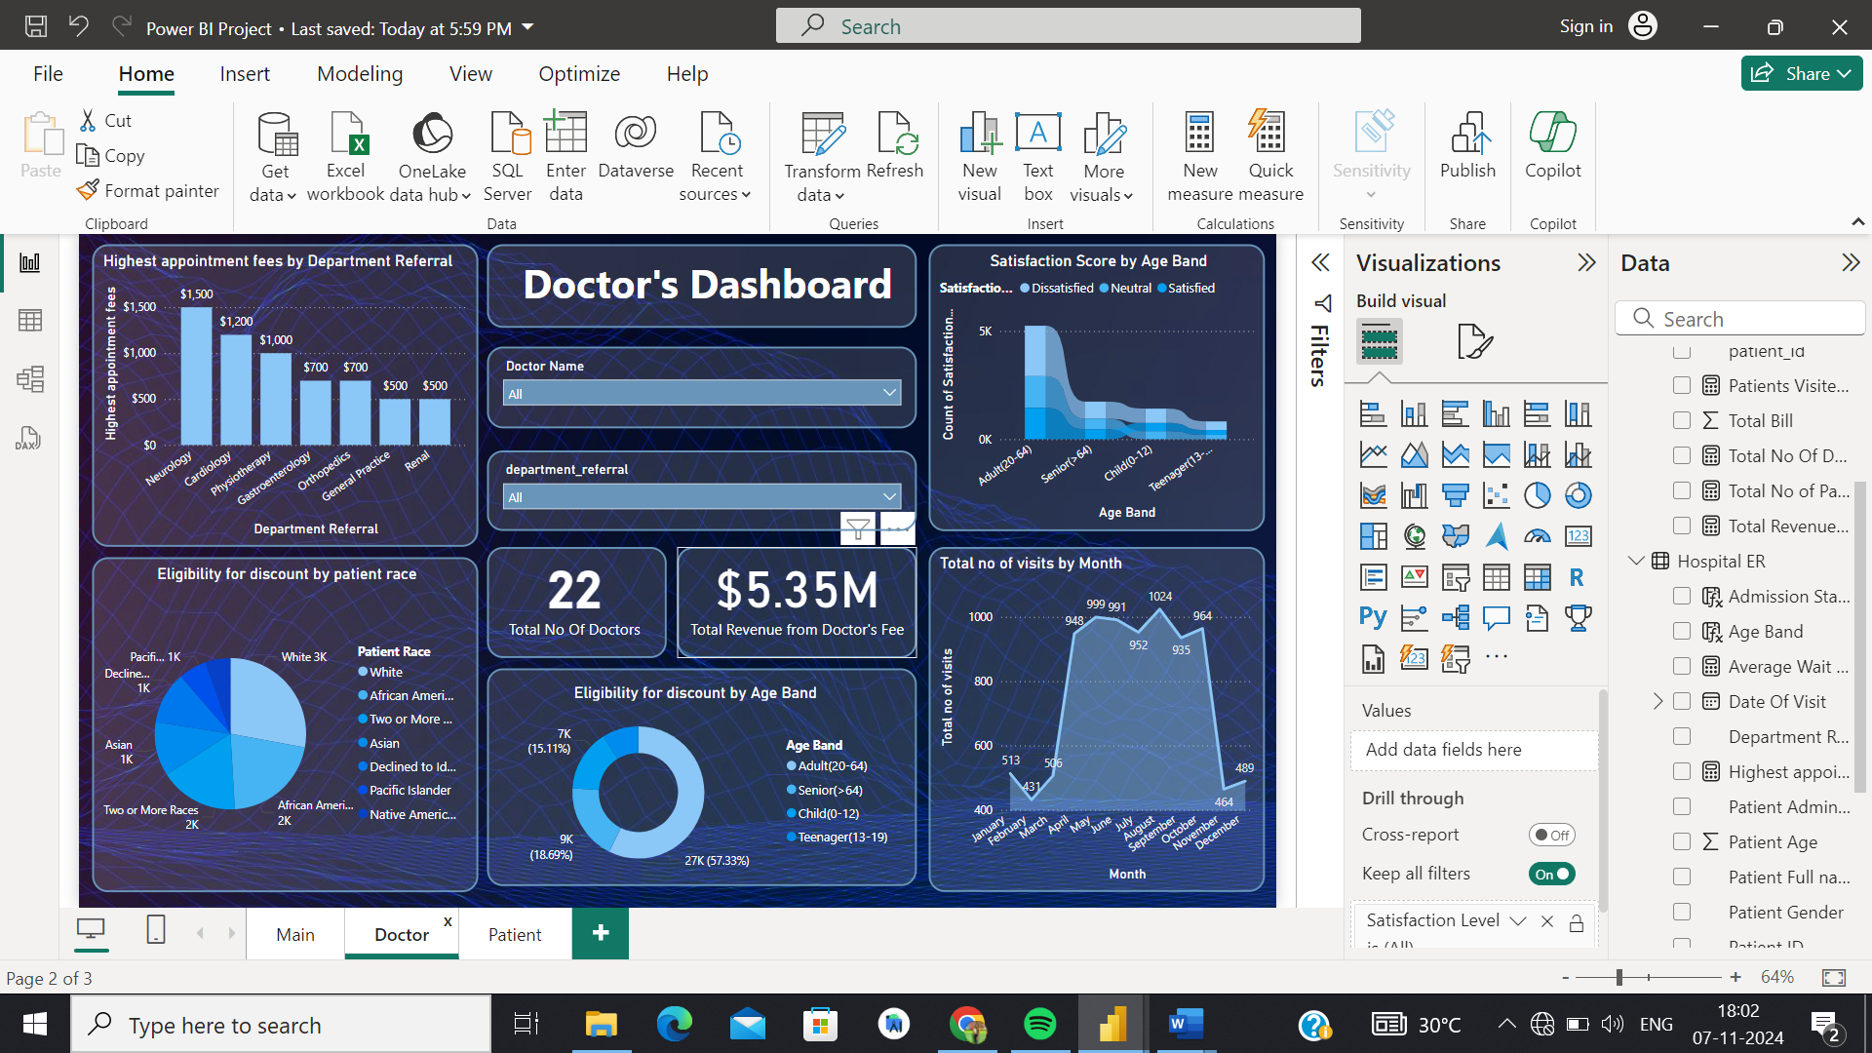

**Observation:** The following aggregation DAX function is used to calculate the highest appointment fees by department:

As seen above, the highest fee, generally, is charged by the Neurology department.

1. Create a tabular visualization in the Report view which consists of Month-wise total visits in the hospital.  Add a third column in the table that consists of the previous month’s total visits for each month’s row. Also, include a column that states whether the visits in a month are greater than that of the previous month's visits.

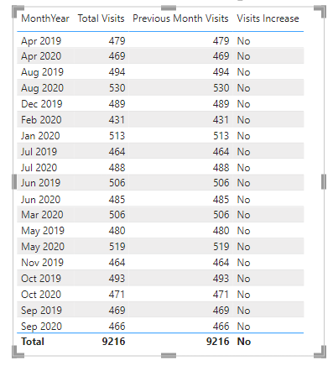 **Visualization:**

The following is a bar-chart visualization of the above table for easier comprehension of data:

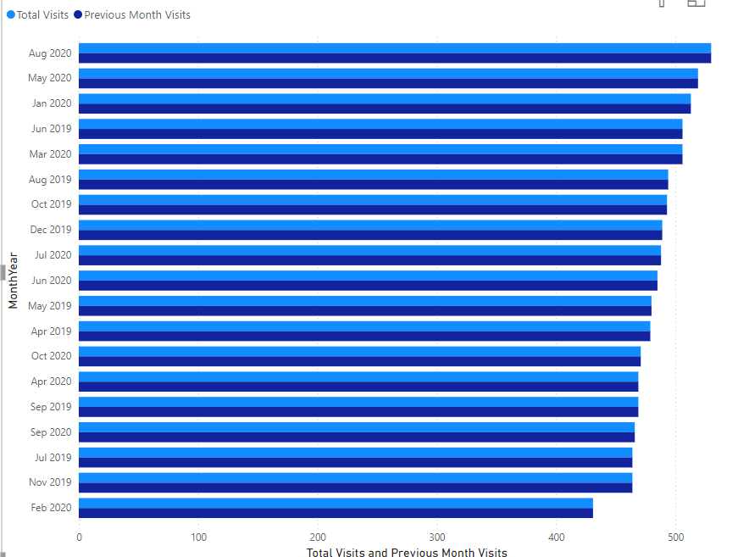

1. Using ‘Calculate’ and a row iteration DAX function calculate the total number of patients who have visited Dr. Smith.

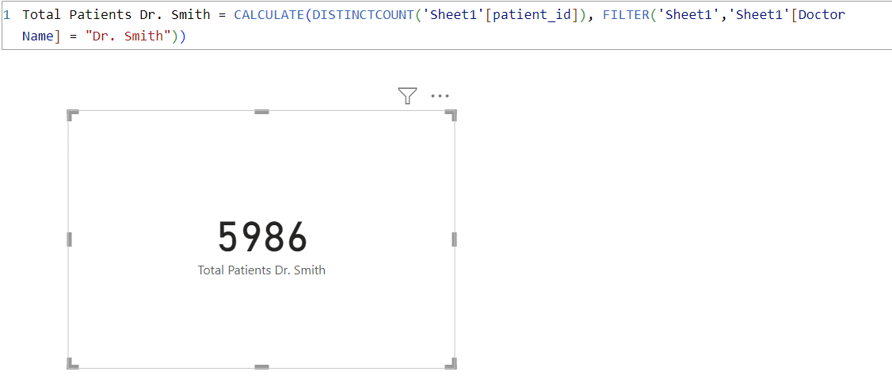 **Visualization:**

**Observation :** We use the following row-iteration DAX function to calculate Dr. Smith’s total patients:

1. Calculate the average age of the patients who visit the Orthopedics department. Will the approach used to calculate this metric be different if the requirement had been all departments’ average age?

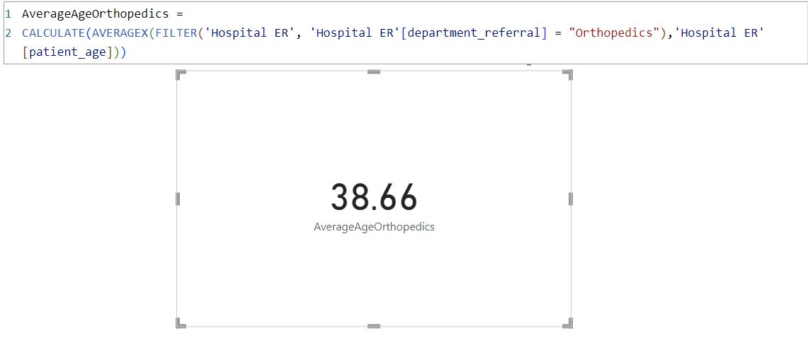 **Visualization :**

**Observation:** We use the following row-iteration DAX function to calculate the average age of the patients who visit the Orthopedics department:

Yes, a different approach would have been necessary in order to calculate the average age of patients from all departments in general, namely, averaging the entire patient_age column without filtering for department.

1. Were there any data format issues in the data, and if there were/are how you handle them?

**Observation:** No data format issues were found in the dataset. Otherwise, to check and handle data format issues, the following procedure would’ve been used.

1. Identify Data Format Issues:

* Ensuring all date columns are in a consistent format.
* Checking that numeric fields contain only numbers and are not mixed with text.
* String fields with unexpected characters or spaces.
* Columns with null or empty values.
* Verifying that each column is stored with the correct data type (e.g., integer, float, date, string).

2. Check for Data Format Issues:

* Inspecting data in the "Data View" to visually check for inconsistencies.
* Using DAX functions like ISNUMBER, ISDATE, ISTEXT, and ISBLANK to create calculated columns or measures that flag potential issues.
* Using Power Query to filter or identify rows with format issues, then applying transformation steps to detect and correct data types.

3. Handle Data Format Issues:

* + Transforming data in Power Query by the "Replace Errors" or "Change Type" options to convert data to the desired format.
  + Creating custom columns to clean or transform data, using functions like FORMAT, VALUE, DATEVALUE, etc.

Alternatively, we could automate data format error-handling by taking steps such as:

* Setting up Data Quality rules/conditional formatting to flag issues.
* Creating summary reports/dashboards that highlight data quality issues, allowing proactive monitoring.

1. When we add a column in Power Query what’s the code that comes in M language in the formula bar? What do you know about M-query?

**Visualization:**

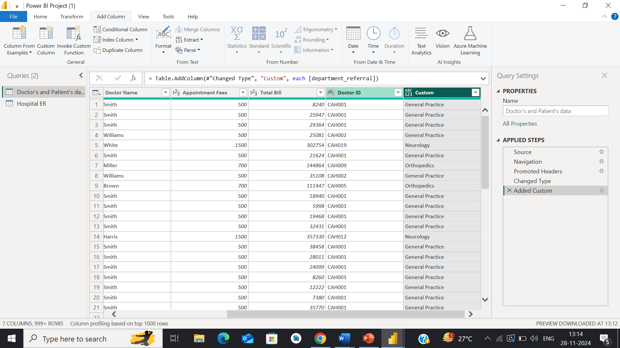

**Observation:** On adding a column in Power Query, the code that appears in the M language formula bar starts with the function name that represents the action being performed. The specific code depends on the type of column added (e.g. a custom column, an index column, etc.).

An M-query is a query written in the M language, which is a data transformation language used in Microsoft Power Query, Power BI, Excel, and other Microsoft data manipulation tools. M (also known as Power Query Formula Language) is designed specifically for data manipulation and transformation, allowing users to import, transform, and combine data from different sources. It is a functional language and treats computations as the evaluation of mathematical functions without changing the state and data. Each query is a series of function applications, building upon the previous one. M supports various data types like text, numbers, lists, records (similar to rows in a table), tables, and more.

**Subjective Questions**

1. What is the relation between patient wait time and satisfaction scores?

**Visualization:**

.

**Insights:** Indicates the relationship between wait time and satisfaction score.

**Approach (Brief):**

1. **Data Analysis**: We segmented wait times and satisfaction scores.
2. **Visualization**: Used a ribbon chart to show the correlation.
3. **Findings**: Longer wait times lead to lower satisfaction.
4. **Actions**: Focused on reducing wait times by optimizing staffing and patient flow.

**Recommendation:** We have used a ribbon chart. As we can see in chart their is a direct correlation between patient wait time and satisfaction scores. An increase in waiting time corresponds to an increase in dissatisfaction scores. So by analysis we found out to increase the satisfaction score we should decrease wait time.

1. How do patient demographics affect the frequency of visits to different departments?

**Visualization:**

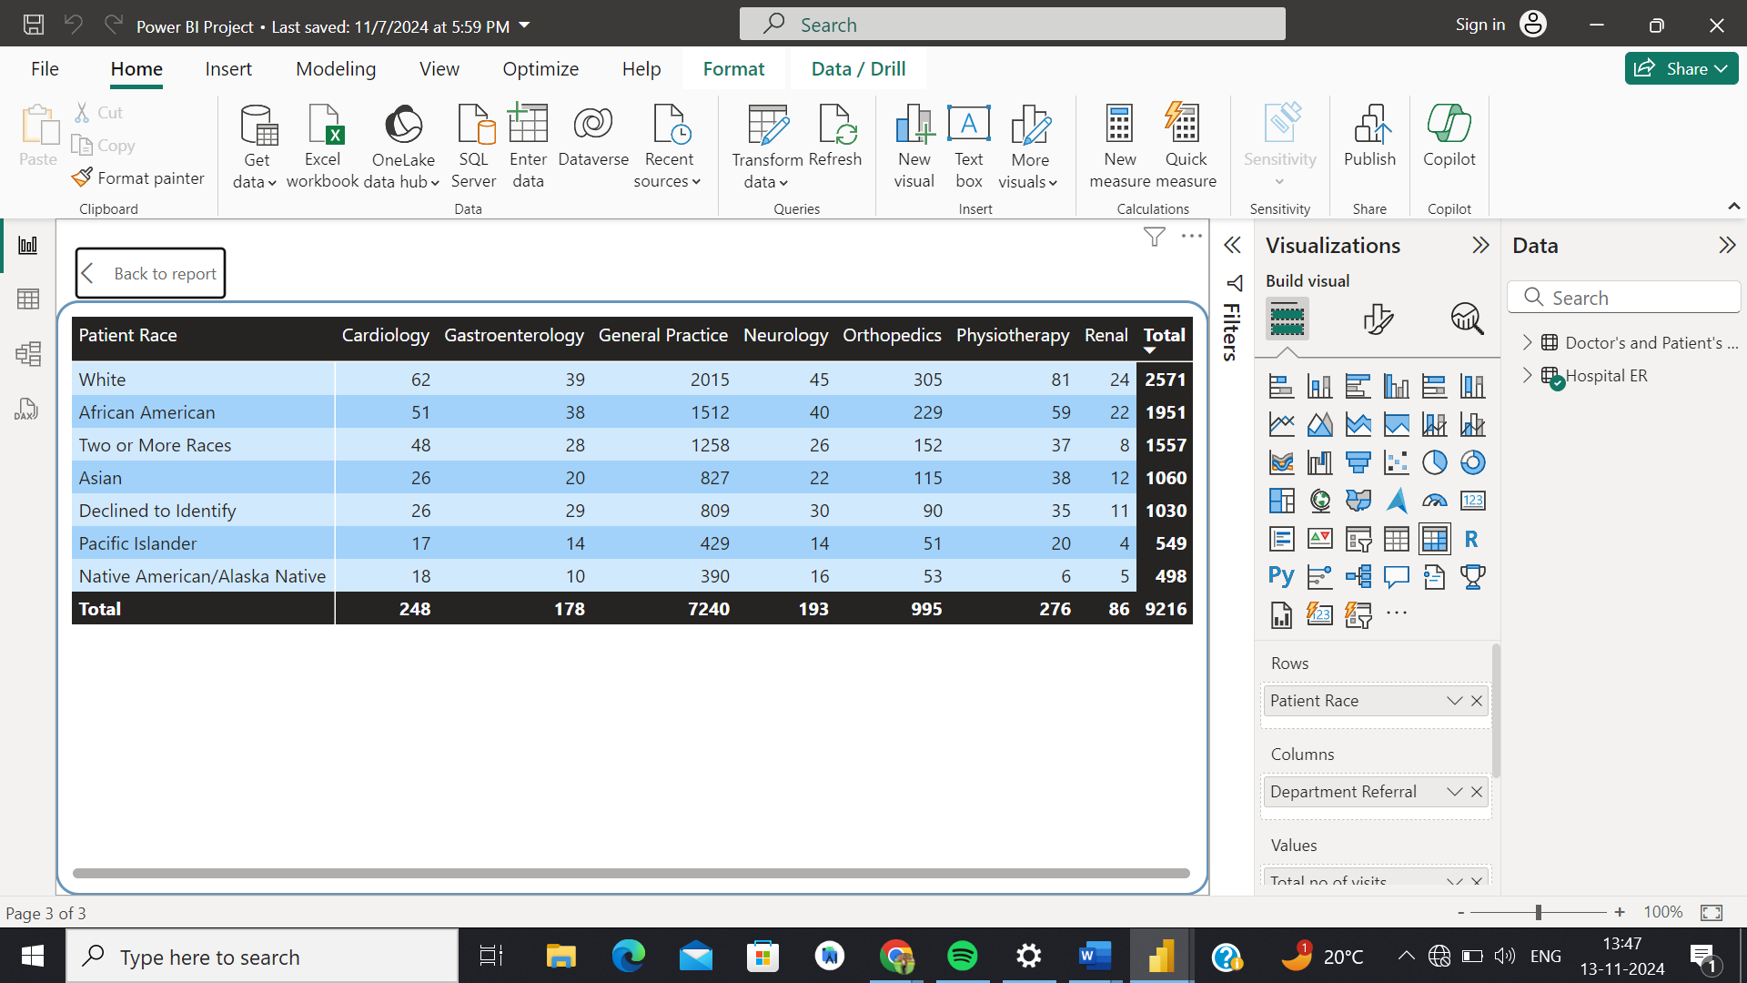

**Insights:** Indicates the patient demographics and number of visits for each department.

**Approach :**

1. **Data Segmentation**: Categorized patients by demographics (e.g., race, age) and tracked visits to departments.
2. **Matrix Visualization**: Used a matrix to show how demographics influence visit frequency across departments.
3. **Trend Analysis**: Found that **White patients** visit the **General Practice department** most frequently.

**Recommendation:** We have use matrix here to show how the patient demographics affect the frequency of visits to different departments .As we can see in the above visualization the General Practice department records the highest number of visits from patients of the White race. Moreover, when considering the overall data, patients of the White race emerge as the most frequently visited across all departments.

1. Is there a noticeable trend in the volume of patient visits throughout the year?

**Visualization:**



**Insights:** Indicates the total number of visits by month

**Approach :**

1. **Data Collection**: Gathered monthly data on patient visits.
2. **Visualization**: Used an **area chart** to track visit trends throughout the year.
3. **Analysis**: Identified a sharp increase in visits from **April to October**, with lower visits in **January to March** and **November to December**.
4. **Actionable Insights**: Focus on **optimizing resources** during peak months and plan for **staff adjustments** during slower months.

**Recommendation:** We have use area chart to find is their any noticeable trend in the volume of patient visits throughout the year. Certainly, there has been a sudden increase in the number of patient visits from April to October. Patient volume is relatively lower during January to March and in November to December.

1. Which age groups report the highest and lowest satisfaction scores?

**Visualization:**



**Insights:**  Indicates the satisfaction score by age band

**Approach:**

1. **Data Collection**: We segmented satisfaction scores by different **age groups** to identify patterns.
2. **Visualization**: A **ribbon chart** was chosen to track how satisfaction scores vary across age bands.
3. **Trend Identification**: Analyzed the chart to find that adults (20-64 years) had higher scores, while teenagers (13-19 years) had lower scores.
4. **Actionable Insights**: Suggested **targeted feedback** for teenagers to understand their specific concerns, aiming to enhance satisfaction in this age group.

**Recommendation:** We have used ribbon chart to determine the highest and lowest satisfaction scores .The age range from 20 to 64 years(adult) exhibits the highest level of satisfaction scores and age range from 13 to 19 years (teenagers) have the lowest level of satisfaction scores. Conduct surveys or feedback sessions to understand specific pain points affecting satisfaction for this age group.

1. Say someone outside of the hospital claims that there is racial or gender-based discrimination in the hospital, how will you identify whether the claim was right or not?

**Insights:** To identify whether there is racial or gender-based discrimination in the hospital, we carry out a structured analysis of the patient data, focusing on comparing the treatment, frequency of visits, and outcomes across different racial and gender groups.

**Approach:**

1. **Data Collection** – Ensure accurate gender, race, visit, billing, and satisfaction data.
2. **Trend Analysis** – Compare visit frequency, spending, and satisfaction across groups.
3. **Satisfaction Check** – Identify dissatisfaction trends by gender and race.
4. **Statistical Testing** – Verify significant differences in spending and satisfaction.
5. **Visualization** – Use matrix to highlight key patterns.
6. **Insights & Action** – Address dissatisfaction, ensure fairness, and improve patient experience.

**Visualization:**

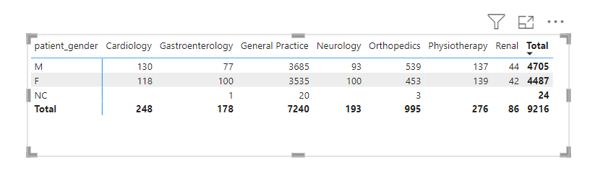

From the gender breakdown above, we find that males make more visits to cardiology, general practice, orthopedics and renal, while females make more to gastroenterology, neurology and physiotherapy, and that males in general comprise slightly more visits.

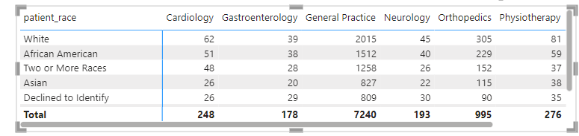

From the racial breakdown above, we find that Whites make up the most visits to all departments, and Asians/DTIs (overall) the least.

Additionally, we tabulate satisfaction scores across gender and race for more thorough verification:

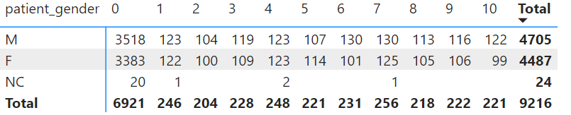

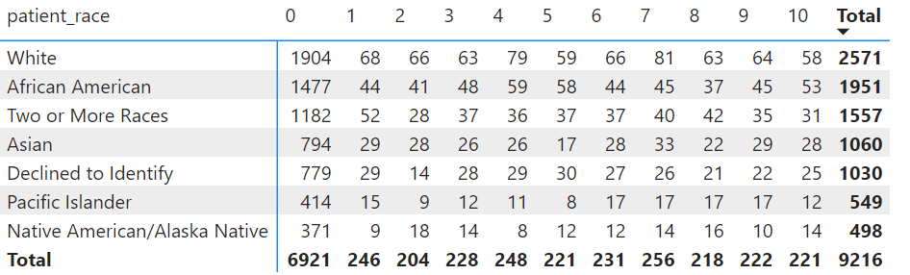

Gender-Based Analysis**:** The total number of patients for each gender is nearly even: 4,705 males (M) and 4,487 females (F). Both males and females have a consistent spread of satisfaction scores across all levels. The highest number of patients for both males and females is at satisfaction score 0, which could indicate a dissatisfaction trend.

Race-Based Analysis: The largest racial group is White patients (2,571), followed by African American (1,951) and those identifying as Two or More Races (1,557). White patients have a broad distribution of satisfaction scores, but a significant number (804) rated their satisfaction at 0, which is the highest for this group. African American patients also show a high number of 0 satisfaction scores (474), suggesting dissatisfaction, but they have slightly more evenly spread satisfaction scores across the spectrum compared to White patients.

Additionally, we tabulated satisfaction scores across gender and race for the average of the total bill:

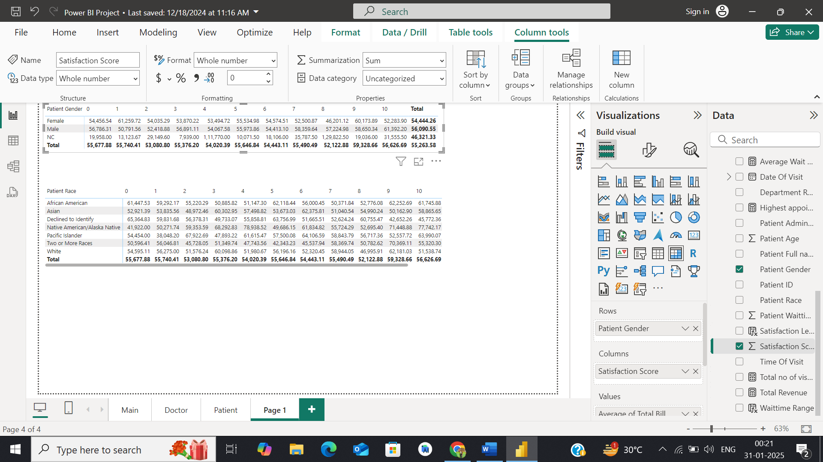

Gender-Based Trends:

* Males (₹56,090.55) have a higher average total bill than Females (₹54,444.26).
* Spending is fairly consistent across satisfaction scores, but score 0 has the highest spending for both genders, which may indicate dissatisfaction.



Racial Analysis:

1. Highest Spending by Race:"Declined to Identify" group has the highest spending at score 0 (₹65,364.83), indicating dissatisfaction.Native American/Alaska Native patients have high spending at score 4 (₹69,292.83) and a score 10 (₹72,742.17).African American patients have a peak at score 10 (₹61,745.88), suggesting higher satisfaction.
2. General Trends: The highest total spending is at satisfaction score 10 (₹56,626.69), indicating satisfied patients tend to have higher bills. Satisfaction score 0 also has high spending (₹55,677.88), reflecting potential service issues.

Conclusion: No differences exist between males and females in satisfaction scores. This is not the case for racial differences, particularly with a high number of dissatisfaction scores in certain racial groups.

1. The hospital management intends to offer discounts to patients. How should these offers/discounts be assigned to patients, on what basis, and why?

**Approach:**

* **Satisfaction-Based Discounts:** Helps address low satisfaction and improve patient perception.
* **Demographic-Based Discounts:** Supports specific needs of elderly and young patients.
* **Frequency-Based Discounts:** Rewards loyalty and encourages return visits.
* **Cost-Based Discounts:** Eases financial strain for patients in high-cost treatments.

**Recommendation:** When assigning offers or discounts to patients, the hospital management should consider multiple factors to ensure that the discounts are both fair and effective in improving patient satisfaction and engagement.

1. Based on Satisfaction Scores: Patients who have reported low satisfaction scores should be prioritized for discounts. Offering discounts to these patients can help improve their perception of the hospital and encourage them to return, potentially boosting their satisfaction in the future.

2. Based on Demographic Factors: Elderly patients, who often require more frequent visits and treatments, could be offered discounts to reduce their financial burden. Alternatively, young patients might be targeted with discounts to encourage early preventive care.

3. Based on Frequency of Visits: Patients who visit frequently could be rewarded with discounts as a form of loyalty incentive. E.g., after a certain number of visits, a patient might receive a discount on their next visit.

4. Target High-Cost Departments: Patients who frequently visit departments associated with high costs (e.g., oncology, surgery) might benefit from discounts to reduce financial strain.

1. The hospital has a budget to hire 2-3 new doctors. They have asked for your suggestions on which departments they should hire.

**Visualization:** 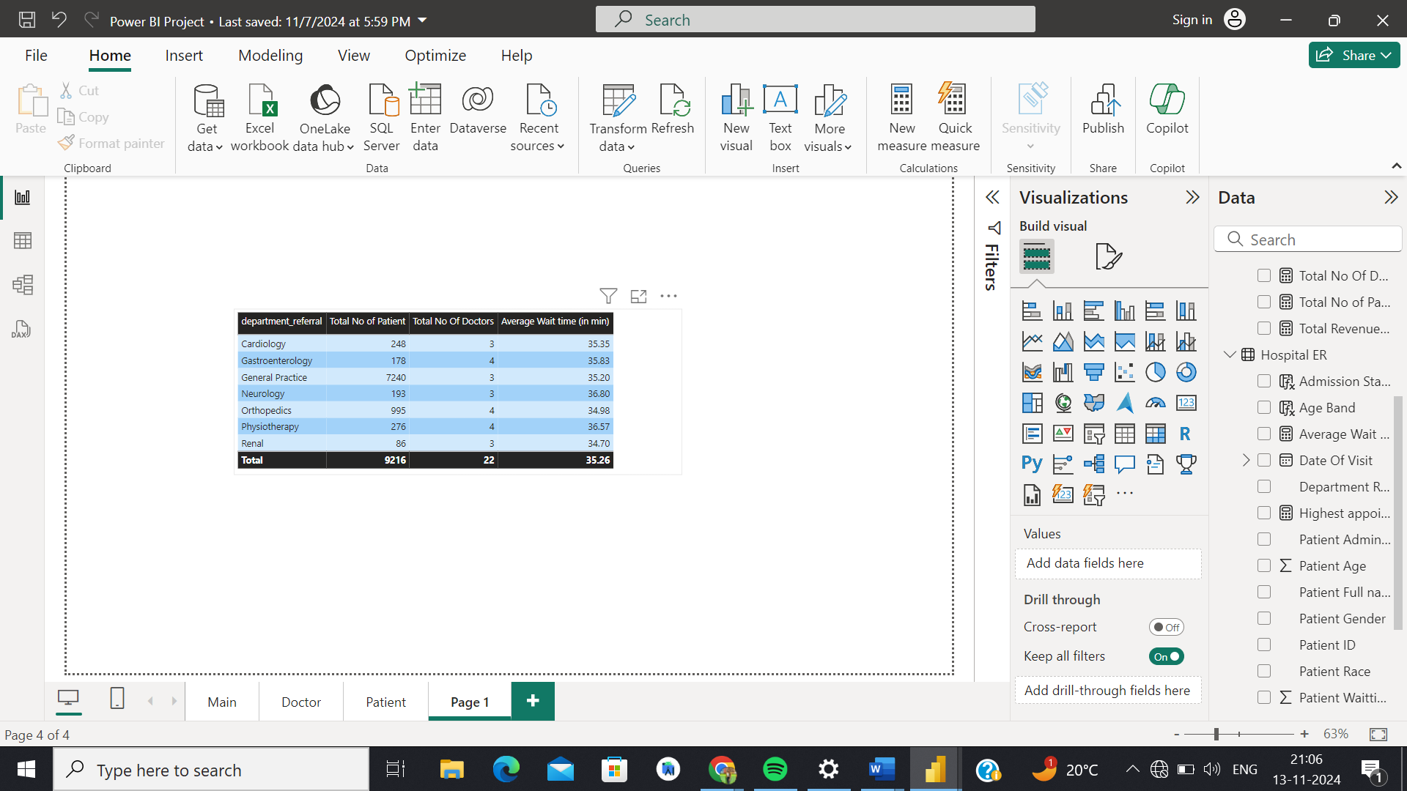

**Insights :** Indicates the department referral ,total no of patient ,total no of doctors and average Wait time.

**Approach:**

1. **Analyze Data**: Visualize patient volume, doctor count, and wait times by department.
2. **Identify Need**: Focus on departments with high patient loads and long wait times but few doctors.
3. **Estimate Impact**: Assess how adding doctors could reduce wait times and increase revenue.

**Recommendation:** If the hospital budget permits, it is advisable to explore the option of recruiting additional doctors for the General Practice department. Currently, this department accommodates the highest volume of patients with only three doctors. Increasing the number of doctors is likely to reduce patient wait times, elevate satisfaction levels, and potentially enhance overall hospital revenue.

1. Is the hospital profitable? How will you determine the profitability?

**Approach:**

1. **Data Review**: Examine the dataset to ensure it includes key components like the **Total Bill** (revenue) and **Expenses**.
2. **Calculate Total Revenue**: Use a SUM function on the **‘Total Bill’** column to determine the hospital’s total revenue.
3. **Calculate Total Expenses**: Similarly, use a SUM function on the **‘Expenses’** column to calculate the hospital’s total expenses.
4. **Profit Calculation**: Subtract **Total Expenses** from **Total Revenue** to calculate the **Profit (or Loss)**.

**Formula**:  
**Profit (or Loss)** = **Total Revenue** - **Total Expenses**

1. **Interpret Results**: If the result is positive, the hospital is profitable. If negative, the hospital is incurring a loss.

**Recommendation:** Analysing the hospital's profitability is challenging with the current dataset. While the dataset indicates the total revenue generated by the hospital, a comprehensive analysis of profit and loss requires the consideration of hospital expenses.

To calculate profit(or loss), we would need to first derive the hospital’s total revenue via a measure for SUM of the ‘Total Bill’ column. Then, another measure for the SUM of the expenses column would be subtracted from the first in order to confirm if and how large the hospital’s profit was. Once we have the total revenue and total expenses, we can calculate the **profit (or loss)** by subtracting the total expenses from the total revenue:

Profit (or Loss)=Total Revenue−Total Expenses

1. Any Department for which the waiting time is oddly large?

**Visualization:**



**Insights:** Indicates the department referral, total no of patient, total no of doctors, and average Wait time.

**Approach:**

1. **Data Review**: Analyze the dataset to identify departments, patient volume, doctor count, and average wait times.
2. **Visualization**: Create a matrix or chart comparing wait times across departments.
3. **Identify Outliers**: Look for departments with unusually high average wait times relative to others.
4. **Focus on Neurology**: Highlight **Neurology**, which has an average wait time of 37 minutes, significantly higher than other departments.

**Recommendation:** We have used a matrix to determine which department has an oddly large waiting time. On average, patients experience a waiting time of 37 minutes in the Neurology department, which is notably high compared to other departments. The hospital can hire additional neurologists, nurses, or staff to handle the patient load. We can use patient feedback to uncover hidden inefficiencies.

1. Come up with strategies to provide discounts to the patients.

**Approach:**

1. **Analyze Patient Data**: Segment patients by income, age, visit frequency, and health conditions.
2. **Create Discount Tiers**: Develop discount structures for eligible groups.
3. **Implement Tracking**: Ensure the system tracks visits, payments, and referrals to apply discounts properly.
4. **Promote Programs**: Inform patients about available discounts and promotions

**Recommendation:**

1. Offer discounts based on the patient’s income level. Patients with lower incomes receive higher discounts.

2. Offer discounts to patients who frequently visit the hospital or have multiple appointments.

3. Offer special discounts to elderly patients as well as for pediatric care or young adult services.

4. Patients with chronic conditions that require regular treatment could be eligible for discounts.

5. Offer special discounts during holiday seasons or specific health awareness months.

6. Offer discounts to patients who settle their bills promptly or within a specified time frame. This can encourage timely payments and improve cash flow.

7. Create a referral program where existing patients who refer new patients receive discounts on future services. This can help in patient acquisition and retention.

1. Say you need to align the doctors of the “General Practice” department to work in one of the two shifts, how will you identify what will these two shifts' timings be, and how will you divide the doctors in these two shifts? And also will this 2 shift policy be helpful for the hospital?

**Visualization:**

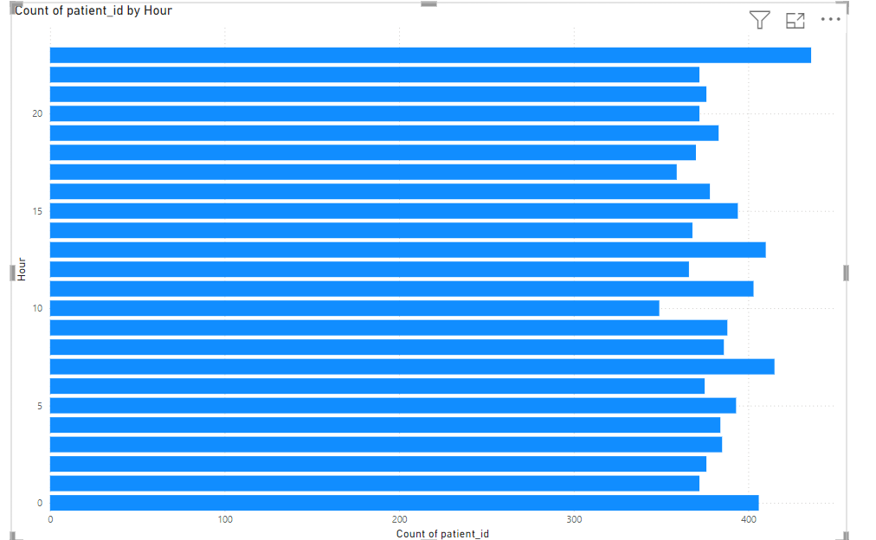

**Insights:** We begin by plotting a bar chart for hour of visit [derived column using the Hour = HOUR('Hospital ER'[date]) expression] against count of Patient ID:

**Approach:**

1. **Analyze Visit Data**: Plot patient visits by hour to identify peak times.
2. **Set Shift Timings**:
   * **Morning Shift**: 6 AM to 2 PM.
   * **Afternoon/Evening Shift**: 2 PM to 10 PM.
3. **Distribute Doctors**: Split the 22 doctors equally, 11 per shift.

**Recommendation:**

The chart shows that visits begin increasing by 6AM, peak from midday to 5PM, and then decline.

Proposed shift timings are thus:

1. Morning Shift: 6 AM to 2 PM: This shift covers the time when patient visits start increasing and goes through the morning.
2. Afternoon/Evening Shift: 2 PM to 10 PM: This shift covers the afternoon peak and extends into the evening, just before visits start to decline.

Ideally, an equal number of doctors should be apportioned to each shift. Since the Hospital has 22 doctors on payroll, each shift could receive 11 each.

1. What do you understand by PowerBI gateway? What are its use cases?

**Insights:** Power BI Gateway is a software that acts as a bridge, allowing secure data transfer between Power BI services in the cloud and on-premises data sources. This is particularly useful when you want to keep your data on-premises for security reasons but still leverage Power BI's cloud-based services for data analysis and reporting. A few essential features are:

**Uses:**

1. The Gateway allows us to connect to various on-premises data sources like SQL Server, Oracle, SAP, and files stored in network folders.
2. Enables the scheduling of automatic data refreshes, ensuring that Power BI reports and dashboards always display the latest information from on-premises data sources.
3. Power BI Gateway supports DirectQuery, which allows running live queries against on-premises data sources, ensuring real-time data availability in reports.
4. Central management of all gateways in the Power BI service, including adding data sources, monitoring gateway health, and configuring gateway settings.

Power BI Gateway’s use-cases include:

* When an organization has sensitive data stored on-premises that needs to be kept secure while still using Power BI's cloud services.
* When we need to schedule automatic refreshes for reports that connect to on-premises data.
* When we require real-time data reporting using DirectQuery.

1. How would you approach this problem, if the objective and subjective questions weren't given?

**Approach:**

1. **Explore Data:** Analyze key metrics like patient volume, visit timings, and revenue.
2. **Visualize Trends:** Create charts to identify patterns across departments and time.
3. **Identify Core Metrics:** Focus on patient satisfaction, staffing, revenue, and wait times.
4. **Advanced Analysis:** Perform segmentation, profitability, and satisfaction analysis.
5. **Formulate Recommendations:** Use insights to suggest improvements for hospital operations.

**Recommendation:** Without the guiding objective/subjective questions, I would have attempted to gather my own observations by experimenting with differing permutations of the dataset’s given metrics, visualizing each to better understand potential trends or patterns pertaining to a certain demographic, department or time of year.

Next, I would decide key objectives by identifying core metrics that would be valuable to the hospital management. Also essential would be to consider what hospital management, doctors and patients might want to know.

After this, I would conduct more advanced analysis, such as segmentation analysis to understand the behavior and outcomes of different patient groups, profitability analysis to compare revenues and costs across departments & satisfaction analysis to pinpoint areas needing improvement.

The insights gained from these analyses may then be integrated towards actionable recommendations for hospital management.

1. Can you analyze and write the type of relationship between the doctor id and department, is it one-to-one?

**Visualization:**

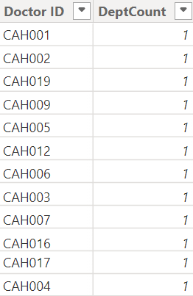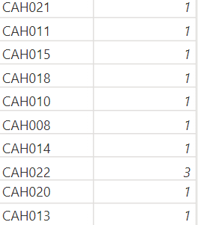

**Approach:**

1. **Analyze Data:** Check how many departments each doctor is linked to.
2. **Create Table:** Use DAX expression to summarize distinct departments per doctor.
3. **Visualize:** Plot the data to observe if doctors are linked to multiple departments.

**Recommendation:** To investigate the relationship between these attributes, we begin by deriving a new table for distinct departments per doctor, using the following DAX expression:

DoctorDeptCount = SUMMARIZE(Sheet1, Sheet1[Doctor ID], "DeptCount", DISTINCTCOUNT(Sheet1[department_referral])

As seen in the visualization, one of these doctors, namely CAH022, links to multiple departments. Thus, not every row has a DeptCount of one and the relationship is one-to-many.